**“** **Railway Reservation System”**

Data Flow Diagram

Definition of DFD:

The data flow diagram is a graphical representation that depicts information flow and the transforms that are applied as data moves from input to output. The DFD may be used to represent a system or software at any level of abstraction. In fact DFD may be partitioned into levels that represent increasing information flow and functional detail.

**LEVEL 0 DFD OR CONTEXT FREE DIAGRAM:**

The level 0 DFD or a context model represents the entire software element as a single bubble with input and output data indicated by incoming and outgoing arrows, respectively.

In level 0 diagram shown below, the passenger fills either the reservation or cancellation form as input. He gets the ticket as the output and the report is sent to the administration.

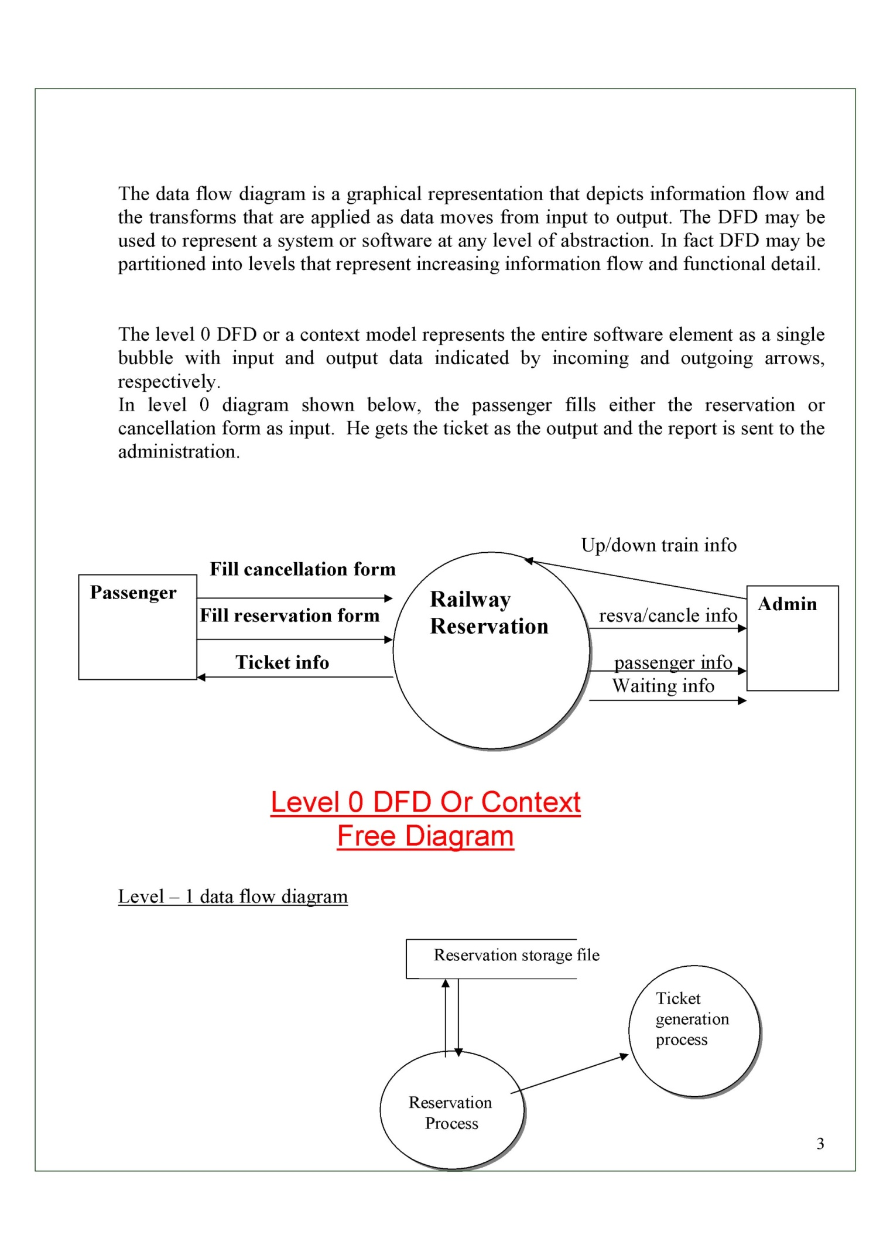

**LEVEL 2 DFD:**

A level 1 DFD is the furthur refinement of level 0 DFD showing greater details and functionalities. In this, the single bubble of level 0 DFD is refined furthur . Each of the processes depicted at level 1 is a subfunction of the overall system depicted in the context model.

As shown in the DFD above, the passenger either enquires about the trains or goes directly for the reservation or the cancellation processes as a result of which he gets the ticket generated. The reports are then sent to the administration

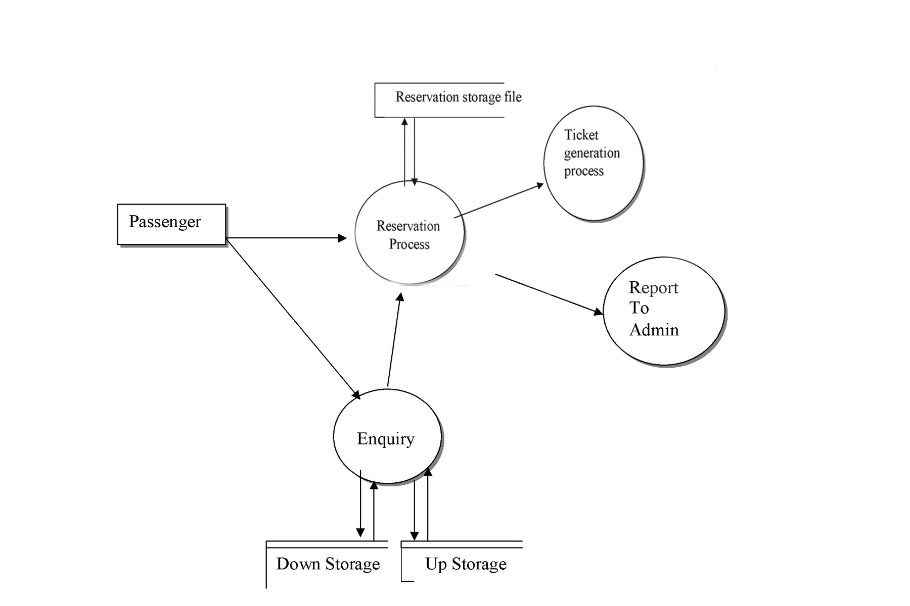

Level 2 DFD :

The level 2 DFD is the further refinement of the level 1 DFD. As shown in the DFD above the passenger has many options like he can directly go to the reservation counter or can first inquire and then go to the reservation counter or he can just inquire and return back. If the passenger wants reservation then the seats are checked for availability and if the seats are available the confirmation ticket is generated otherwise he is asked for waiting and waiting ticket is generated if he wants. If the user wants tickets to be cancelled he is given the cancellation ticket and the reports of all the transactions are sent to the administrator.

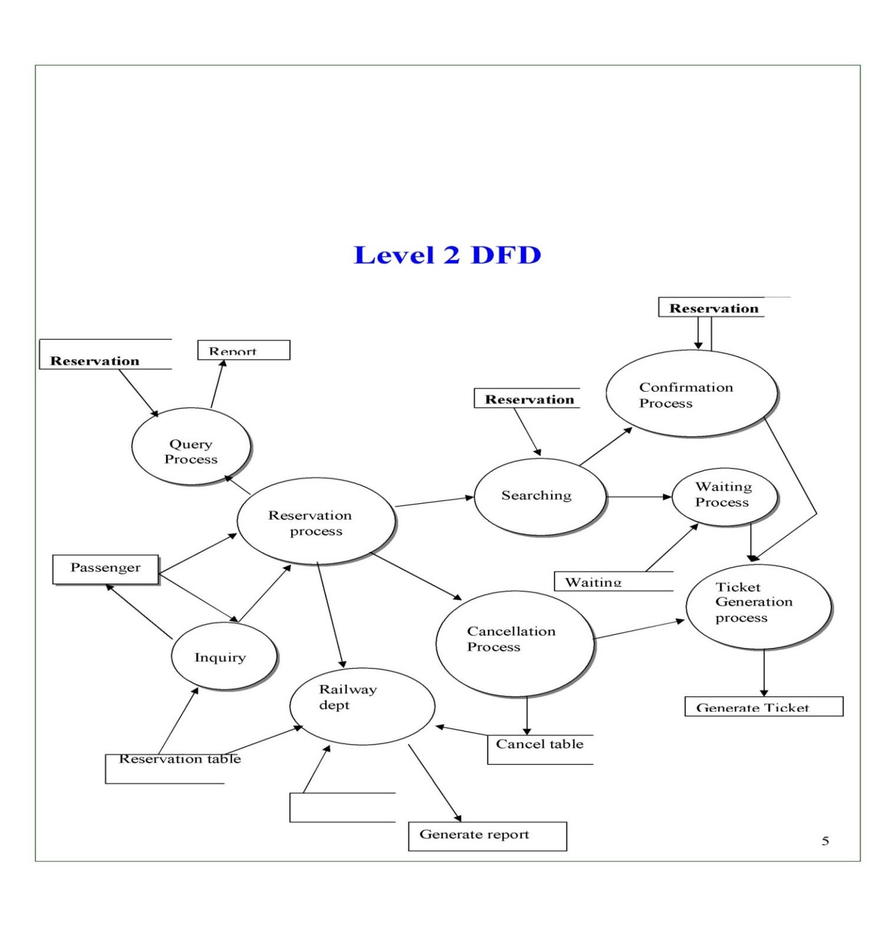

**Entity Relationship Diagram**

The entities and their attributes are: -

1. Passenger

#. Name

*. Full name

#. Gender

#. Age

1. Form

#. Form no.

1. Ticket

#. Ticket no.

*. Waiting

*. Confirmed

*. Cancelled

1. Reservation counter
2. Administrator
3. Train

#. Train no

#. Train name

#. Source

#. Destination

1. Seat

#. Seat no.

### The relationships between different entities are: -

1. Fill: The passenger fills the form.
2. Submit: The form is submitted to the reservation counter.
3. Check: The reservation counter checks the seats.
4. Generate: Reservation counter generates the ticket.
5. Issue: Reservation counter issues ticket to the passenger.
6. Send info: The reservation counter sends information to the administrator.
7. Allotted: The seat is allotted in the train.

|  |  |
| --- | --- |
| **Symbols** | **Meanings** |
|  | Data flow |
|  | Process |
|  | Data store |
|  | Entity |

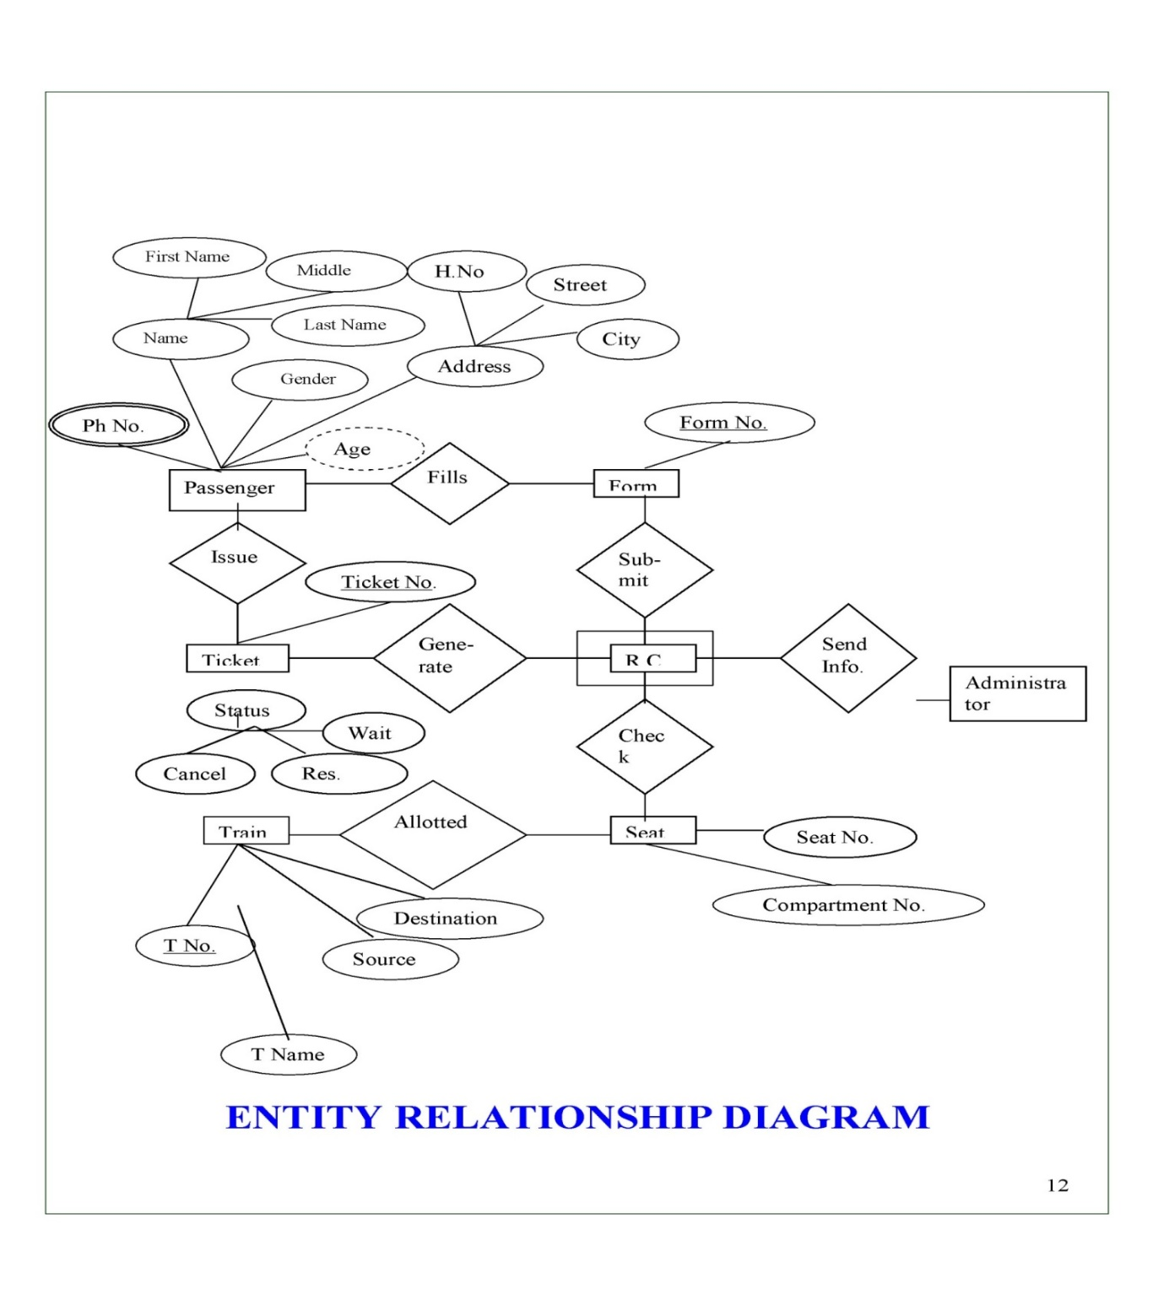

**Activity Diagram**

